

DEEPAK KALONIA JANGRA
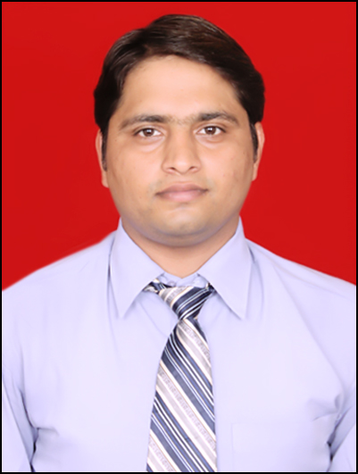

Room no. 612, Auto point hostel,
New Mumbai pune Expressway
Mobile : 8600709713
E-mail: deepak.kalonia@indiraisbs.ac.in
deepak.kalonia@gmail.com

Specialization:
Core Marketing

Education:

PGDM (Marketing) | Indira School of Business Studies | Autonomous | 2012-2014 | 65.92%  (first year)
BE  (ECE) | PDM College of Engineering | M.D.U Rohtak | 2005-2009 | 57.93%
HSC  (PCM) | K.V.N o1 Colaba Mumbai | C.B.S.E | 2004 | 55.4%
SSC | K.V.No1 Colaba Mumbai | C.B.S.E | 2002 | 61.8%

Project Details:
Company: Revenir development system pvt. Ltd.
Project Title: “To identify the evaluation criteria for the purchase of ERP product among MSME in
Delhi region”
Duration: 15th May13 to 30thJune13.
Details:
- Diligently worked under the C.E.O (Chief executive officer) in league the sales executive

- Facilitate problem-solving meetings with the HR/IT head/Admin head of organizations and followed by visit, presentation, follow ups and consultation

- Created and implemented innovative approach for sales boost by directly reaching out to the target segment and Investigating the problems

- Analysed and Identified the criteria for the purchase of ERP product among MSME in Delhi-NCR by conducting the Market Research
Achievement:
- Successfully Completed the Project within the given time
- Got Appreciation from the Sr. Manager for Excellent Performance

Computer Skills:
Operating Systems: Windows2000, Windows-XP, Windows 7
Packages Known: Microsoft Office 2007/2010 (Word, Excel, Power Point)

Additional Qualification:

- Currently undergoing a 250-hour comprehensive performance-based Leadership Development Programme by Stratecent Consulting, and have acquired the following skills:

    - Negotiation Skills
    - Problem Solving Skills
    - SPIN Selling
    - System thinking
    - Strategy
    - Team

Certifications:

- 30 hours course on ‘C LANGUAGE’ from Ap-tech Computer education, Visakhapatnam in the year 2008

Extra Curricular Activities:

- Participated in the “RUN FOR HEALTH” on the occasion of golden jubilee celebration of INHS ASVINI on 9th September 2001.
- Active participant in extempore and GD sessions held during schooling as well as in college
- Organized blood donation camp in my engineering college
- I donate blood voluntary two times within a year.
Personal Details:

Date of Birth: 15/01/1985
Marital Status: Single
Strengths:
- Team Player
- Adaptable
- Helpful/Caring
- Learning Attitude
- Self disciplined

Languages: English, Hindi, Haryanvi

